Ecoregions Webquest

These pictures were taken at different places in Texas, close to the Colorado River.
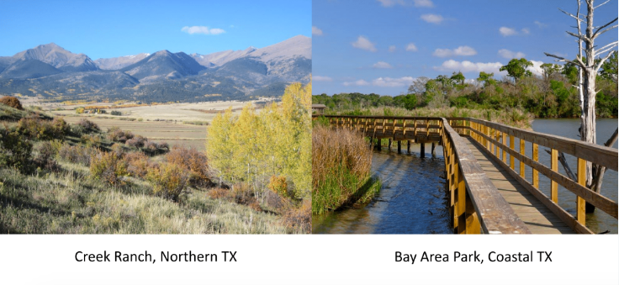
What are three differences that you notice between them?
1.________________________________________________________________________
2.________________________________________________________________________
3.________________________________________________________________________

The differences that you notice here are what make up Ecoregions!

What is an ecoregion? Ecoregions are areas of land where ecosystems and environments are generally similar.

Check out this map and find out which ecoregion you live in! Link: https://tpwd.texas.gov/publications/pwdpubs/media/pwd_mp_e0100_1070ac_34.pdf

What ecoregion(s) is Austin in? ____________________________________________
Ecoregions Webquest

As you can see from the graphic below, the Texas Colorado River spans across MANY ecoregions in Texas. The pictures that you compared at the beginning of this lesson were both taken close to the Texas Colorado River, which gives you a small picture of how diverse our river basin is!
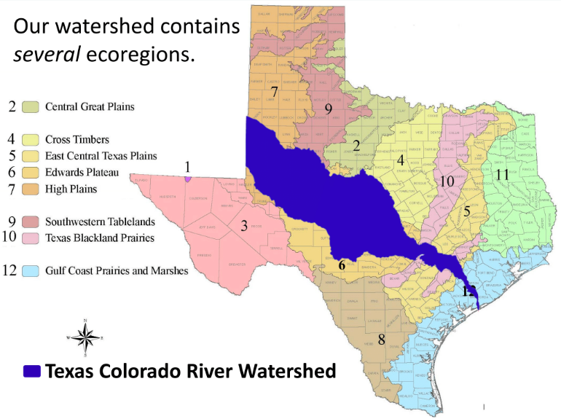
Become familiar with the different Texas Ecoregions by checking out these facts and watching the videos on the TPWD website.
Using the space below, compare and contrast the High Plains ecoregion (where the Colorado river starts) with the Gulf Coast Prairies and Marshes ecoregion (the mouth of the Colorado River). You can use descriptors such as elevation, wildlife, vegetation, and terrain.
Ecoregions Webquest

The movement and amount of water affects everything within an Ecoregion. Look at these pictures and compare how the landscape with fast moving water is different from the landscape with slow-moving water. Look at things like where the plants are growing, the clarity of the water, and the types of rocks that you see in each picture.
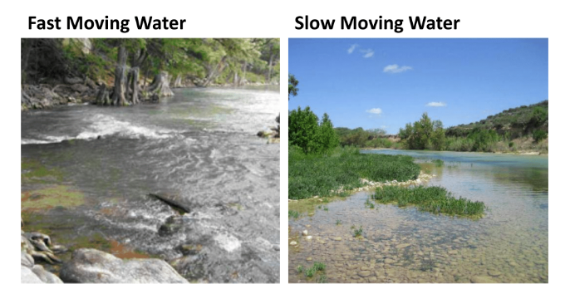

List three differences you notice in these pictures:
1.________________________________________________________________________
2.________________________________________________________________________
3.________________________________________________________________________

There are three key process that help shape Texas Ecoregions: Weathering, Erosion, and Deposition. Watch this video and then fill in the definitions below! Link: https://www.youtube.com/watch?v=R-Iak3Wvh9c&feature=youtu.be
Weathering: | Erosion: | Deposition:
Ecoregions Webquest

These processes are driven by environmental forces. Check out this game to see what types of environmental forces drive Weathering, Erosion, and Deposition! Play the game until you have used all the different forces of nature!

Click here to play the game! Link: http://sciencenetlinks.com/interactives/shapeitup.html
Note: You might need to click “allow” for your browser to enable Flash Player.

What were the four forces of nature that can influence the landscape?

Watch this video to learn about how weathering, erosion, and deposition shape the landscape surrounding the Colorado River! (Insert link for CRA Streamtable video here)
After watching the video, answer the following questions!
Was erosion happening more on the inside curves of the river, or the outside curves?
_____________________________________________
Where did you see the sediment being deposited?
_____________________________________________
Did you see weathering happening? If so, where?
_____________________________________________

Another force of nature that has a great effect on our ecoregions in Texas is GRAVITY! How do you think that gravity helps shape the landscape and ecoregions?
____________________________________________________________________________________________________________________________________________________________________________________________________________________________________________________________________________

