Runoff and Infiltration Webquest

When rain hits the ground, what happens to it?

Watch this video to review the Water Cycle and use the information to fill in the diagram and answer the following questions! Link: https://oceantoday.noaa.gov/watercycle/

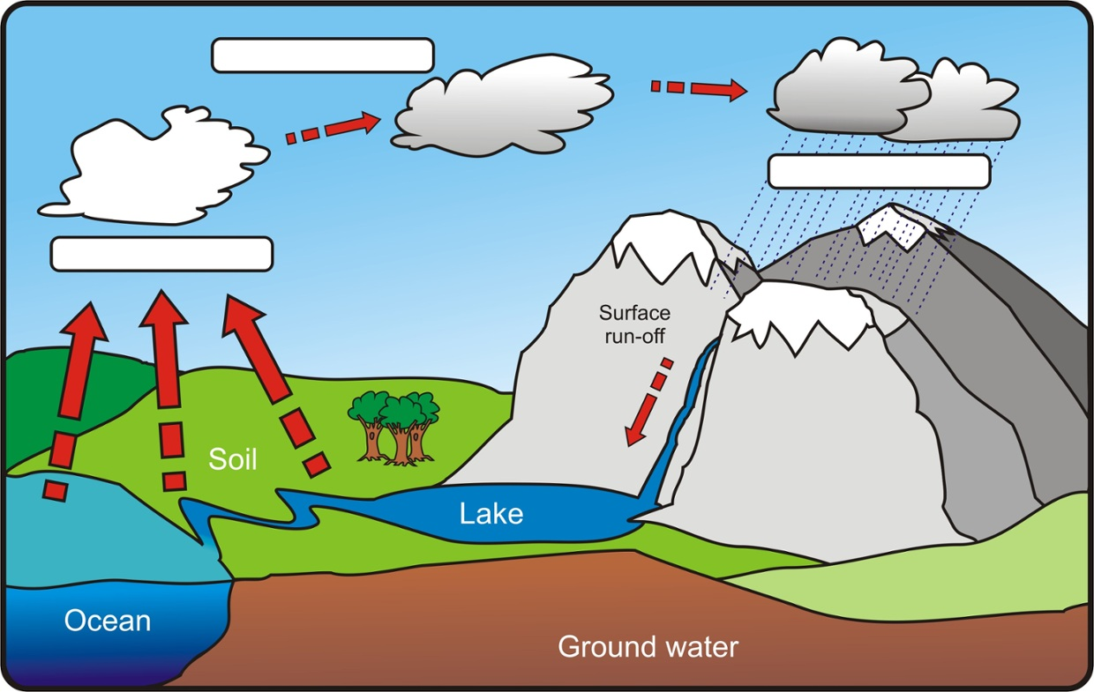
2.

.

3.

1.

- What does it mean for water to infiltrate?

- What does it mean for water to runoff?

Runoff and Infiltration Webquest

Look up the definition of impervious cover and write it in the box below, along with three examples.
Impervious Cover Definition: | Examples of Impervious Cover:

When we have a lot of impervious cover, there is a lot of runoff. We don’t have as much infiltration because the water cannot reach the ground. Infiltration is important because it allows aquifers to be filled up. Also, when there is a lot of runoff, we have more flooding events. Look at the image below and record the differences between an area covered in natural vegetation compared to a city area with lots of impervious cover.
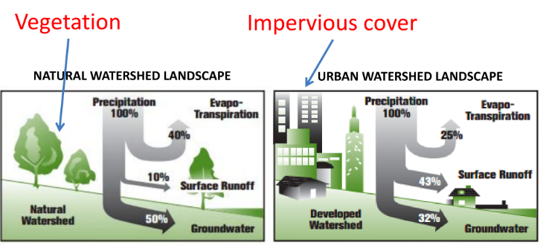

What percentage of water runs off in a natural landscape? ________________________________________
What percentage of water runs off in an urban landscape? ________________________________________
What percentage of water infiltrates into the ground in a natural landscape? _______________________
What percentage of water infiltrates into the ground in an urban landscape? _______________________
How can an increase in runoff affect a city? Check out this video showing images of the city of Houston before and after Hurricane Harvey in 2017. https://www.youtube.com/watch?v=YzQGgyrxXiI
Runoff and Infiltration Webquest

Do you think that the impervious cover present in Houston could have had an influence on the flooding in Houston? Why or why not?

List two reasons why the ability for water to infiltrate is important:
1.

2.

Runoff Simulation!
Use the link below to run different simulations and fill in the chart. For each simulation, set the amount of precipitation to 21 cm. Record the different amounts of runoff and infiltration for each type of landscape.
https://runoff.modelmywatershed.org/
Landscape | Amount of Precipitation | Runoff | Infiltration
Developed-High | 21 cm
Developed-Low | 21 cm
Forest | 21 cm

In Austin, we have a thin layer of top-soil that fills up with water quickly. Because of that, we are sometimes called “Flashflood Alley.” What do you think will happen if we were to have multiple rain events in a short period of time? Would there be a lot of runoff or a lot of infiltration? Explain your answer in the box below!
Runoff and Infiltration Webquest

This is an image that shows the Texas Colorado River Watershed! Notice how the basin funnels around the city of Austin.
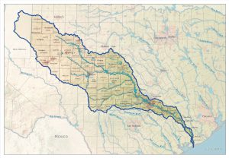

Watch this video to find out what a watershed is.
Link: https://www.youtube.com/watch?v=QOrVotzBNto&feature=youtu.be

Do you think that the shape of the Colorado River watershed can have an influence on flooding in the Austin area? Why or why not?

